ASSIGNMENT NO:1

In [ ]:
NAME: Habibsaeed Mukebil
ROLLNO:14225

In [30]:
import pandas as pd
import numpy as np
import seaborn as sns
import matplotlib.pyplot as plt
import warnings
warnings.filterwarnings('ignore')

In [31]:
df=pd.read_csv("uber.csv") df

Out[31]:
Unnamed:  0 | key | fare_amount | pickup_datetime | pickup_longitude | p

0 24238194 2015-05-07
19:52:06.0000003

7.5 2015-05-07
19:52:06 UTC

-73.999817

1 27835199
2009-07-17
20:04:56.0000002
7.7
2009-07-17
20:04:56 UTC
-73.994355

2 44984355 2009-08-24
21:45:00.00000061
12.9 2009-08-24
21:45:00 UTC
-74.005043

3 25894730
2009-06-26
08:22:21.0000001
5.3
2009-06-26
08:22:21 UTC
-73.976124

4 17610152 2014-08-28
17:47:00.000000188
16.0 2014-08-28
17:47:00 UTC
-73.925023

... ... ... ... ... ...

199995 42598914 2012-10-28
10:49:00.00000053
3.0 2012-10-28
10:49:00 UTC
-73.987042

199996 16382965
2014-03-14
01:09:00.0000008
7.5
2014-03-14
01:09:00 UTC
-73.984722

199997 27804658 2009-06-29
00:42:00.00000078
30.9 2009-06-29
00:42:00 UTC
-73.986017

199998 20259894
2015-05-20
14:56:25.0000004
14.5
2015-05-20
14:56:25 UTC
-73.997124

199999 11951496 2010-05-15
04:08:00.00000076
14.1 2010-05-15
04:08:00 UTC
-73.984395

200000 rows × 9 columns
C C

In [32]:
df.head()

Out[32]:

0 24238194 2015-05-07
Unnamed:  0 | key | fare_amount | pickup_datetime | pickup_longitude | pickup_

19:52:06.0000003

7.5 2015-05-07
19:52:06 UTC

-73.999817 4

1 27835199
2009-07-17
20:04:56.0000002
7.7
2009-07-17
20:04:56 UTC
-73.994355
4

2 44984355 2009-08-24
21:45:00.00000061
12.9 2009-08-24
21:45:00 UTC
-74.005043 4

3 25894730
2009-06-26
08:22:21.0000001
5.3
2009-06-26
08:22:21 UTC
-73.976124
4

4 17610152 2014-08-28
17:47:00.000000188
16.0 2014-08-28
17:47:00 UTC
-73.925023 4

C C
In [33]:
df.info()
<class 'pandas.core.frame.DataFrame'>
RangeIndex: 200000 entries, 0 to 199999 Data columns (total 9 columns):
# Column Non-Null Count Dtype

0 |  | Unnamed: | 0 | 200000 | non-null | int64
1 |  | key |  | 200000 | non-null | object
2 fare_amount |  |  |  | 200000 | non-null | float64
3 pickup_datetime |  |  |  | 200000 | non-null | object
4 pickup_longitude |  |  |  | 200000 | non-null | float64
5 pickup_latitude |  |  |  | 200000 | non-null | float64
6 dropoff_longitude |  |  |  | 199999 | non-null | float64
7 dropoff_latitude |  |  |  | 199999 | non-null | float64
8 passenger_count |  |  |  | 200000 | non-null | int64
dtypes: float64(5), int64(2), object(2) memory usage: 13.7+ MB

In [34]:
df.columns

Out[34]:

In [35]:

In [36]:
df.head()
Index(['Unnamed: 0', 'key', 'fare_amount', 'pickup_datetime',
'pickup_longitude', 'pickup_latitude', 'dropoff_longitude', 'dropoff_latitude', 'passenger_count'],
dtype='object')
df =df.drop(['Unnamed: 0', 'key'], axis =1)

Out[36]:

0 7.5 2015-05-07
fare_amount | pickup_datetime | pickup_longitude | pickup_latitude | dropoff_longitude | dr

19:52:06 UTC

-73.999817 40.738354 -73.999512

1
7.7
2009-07-17
20:04:56 UTC
-73.994355
40.728225
-73.994710

2 12.9 2009-08-24
21:45:00 UTC
-74.005043 40.740770 -73.962565

3
5.3
2009-06-26
08:22:21 UTC
-73.976124
40.790844
-73.965316

4 16.0 2014-08-28
17:47:00 UTC
-73.925023 40.744085 -73.973082

C C
In [37]:
df.shape
fare_amount | pickup_longitude | pickup_latitude | dropoff_longitude | dropoff_latitud

Out[37]: | (200000, | 7)
In [38]: | df.dtypes
Out[38]: | fare_amount  pickup_datetime pickup_longitude pickup_latitude  dropoff_longitude dropoff_latitude passenger_count  dtype: object |  | float64 object float64 float64 float64 float64 int64
In [39]: | df.describe()
Out[39]:
 | count 200000.000000 |  | 200000.000000 | 200000.000000 | 199999.000000 | 199999.00000
 | mean 11.359955 |  | -72.527638 | 39.935885 | -72.525292 | 39.92389
 | std 9.901776 |  | 11.437787 | 7.720539 | 13.117408 | 6.79482
 | min -52.000000 |  | -1340.648410 | -74.015515 | -3356.666300 | -881.98551
 | 25% 6.000000 |  | -73.992065 | 40.734796 | -73.991407 | 40.73382
 | 50% 8.500000 |  | -73.981823 | 40.752592 | -73.980093 | 40.75304
 | 75% 12.500000 |  | -73.967154 | 40.767158 | -73.963658 | 40.76800
 | max 499.000000 |  | 57.418457 | 1644.421482 | 1153.572603 | 872.69762
 | C |  |  |  |  | C

In [40]:
df.isnull().sum()

Out[40]: | fare_amount | 0
 | pickup_datetime | 0
 | pickup_longitude | 0
 | pickup_latitude | 0
 | dropoff_longitude | 1
 | dropoff_latitude | 1
 | passenger_count | 0
 | dtype: int64

In [41]:
df['dropoff_latitude'].fillna(value=df['dropoff_latitude'].mean(), inplace=True)

In [42]:
df.isnull().sum()

Out[42]:

In [43]:

In [44]:

Out[44]:

In [45]:

Out[45]:

In [46]:

In [47]:
df.dtypes
fare_amount 0
pickup_datetime 0
pickup_longitude 0
pickup_latitude 0
dropoff_longitude 1
dropoff_latitude 0
passenger_count 0
dtype: int64
df['dropoff_longitude'].fillna(value=df['dropoff_longitude'].median(), inplace=True
df.isnull().sum()

fare_amount 0
pickup_datetime 0
pickup_longitude 0
pickup_latitude 0
dropoff_longitude 0
dropoff_latitude 0
passenger_count 0
dtype: int64
df.dtypes
fare_amount float64
pickup_datetime object pickup_longitude float64 pickup_latitude float64 dropoff_longitude float64 dropoff_latitude float64 passenger_count int64 dtype: object
df.pickup_datetime = pd.to_datetime(df.pickup_datetime, errors='coerce')

Out[47]:

In [48]:

In [49]:
df.head
fare_amount float64
pickup_datetime datetime64[ns, UTC] pickup_longitude float64
pickup_latitude float64
dropoff_longitude float64
dropoff_latitude float64
passenger_count int64
dtype: object
df= df.assign(hour = df.pickup_datetime.dt.hour, day = df.pickup_datetime.dt.day,
month = df.pickup_datetime.dt.month, year = df.pickup_datetime.dt.year,
dayofweek = df.pickup_datetime.dt.dayofweek)

Out[49]:

In [50]:

In [51]:
df.head
<bound method NDFrame.head of fare_amount pickup_datetime picku

p_longitude | \
0 |  | 7.5 | 2015-05-07 | 19:52:06+00:00 | -73.999817
1 |  | 7.7 | 2009-07-17 | 20:04:56+00:00 | -73.994355
2 |  | 12.9 | 2009-08-24 | 21:45:00+00:00 | -74.005043
3 |  | 5.3 | 2009-06-26 | 08:22:21+00:00 | -73.976124
4 |  | 16.0 | 2014-08-28 | 17:47:00+00:00 | -73.925023
... |  | ... |  | ... | ...
199995 |  | 3.0 | 2012-10-28 | 10:49:00+00:00 | -73.987042
199996 |  | 7.5 | 2014-03-14 | 01:09:00+00:00 | -73.984722
199997 |  | 30.9 | 2009-06-29 | 00:42:00+00:00 | -73.986017
199998 |  | 14.5 | 2015-05-20 | 14:56:25+00:00 | -73.997124
199999 |  | 14.1 | 2010-05-15 | 04:08:00+00:00 | -73.984395

 | pickup_latitude |  |  | dropoff_longitude |  | dropoff_latitude | passenger_count | \
0 | 40.738354 |  |  | -73.999512 |  | 40.723217 | 1
1 | 40.728225 |  |  | -73.994710 |  | 40.750325 | 1
2 | 40.740770 |  |  | -73.962565 |  | 40.772647 | 1
3 | 40.790844 |  |  | -73.965316 |  | 40.803349 | 3
4  ...  199995 | 40.744085  ... 40.739367 |  |  | -73.973082  ...  -73.986525 |  | 40.761247  ... 40.740297 | 5  ...  1
199996 | 40.736837 |  |  | -74.006672 |  | 40.739620 | 1
199997 | 40.756487 |  |  | -73.858957 |  | 40.692588 | 2
199998 | 40.725452 |  |  | -73.983215 |  | 40.695415 | 1
199999 | 40.720077 |  |  | -73.985508 |  | 40.768793 | 1
 | hour | day | month | year | dayofweek
0 | 19 | 7 | 5 | 2015 | 3
1 | 20 | 17 | 7 | 2009 | 4
2 | 21 | 24 | 8 | 2009 | 0
3 | 8 | 26 | 6 | 2009 | 4
4 | 17 | 28 | 8 | 2014 | 3
... | ... | ... | ... | ... | ...
199995 | 10 | 28 | 10 | 2012 | 6
199996 | 1 | 14 | 3 | 2014 | 4
199997 | 0 | 29 | 6 | 2009 | 0
199998 | 14 | 20 | 5 | 2015 | 2
199999 | 4 | 15 | 5 | 2010 | 5

[200000 rows x 12 columns]>
df = df.drop('pickup_datetime', axis =1)

Out[51]:
<bound method NDFrame.head of fare_amount pickup_longitude pickup_latitu

de | dropoff_longitude |  | \
0 | 7.5 |  |  | -73.999817 | 40.738354 |  | -73.999512
1 | 7.7 |  |  | -73.994355 | 40.728225 |  | -73.994710
2 | 12.9 |  |  | -74.005043 | 40.740770 |  | -73.962565
3 | 5.3 |  |  | -73.976124 | 40.790844 |  | -73.965316
4  ... | 16.0  ... |  |  | -73.925023  ... | 40.744085  ... |  | -73.973082  ...
199995 |  | 3.0 | -73.987042 |  | 40.739367 |  | -73.986525
199996 |  | 7.5 | -73.984722 |  | 40.736837 |  | -74.006672
199997 |  | 30.9 | -73.986017 |  | 40.756487 |  | -73.858957
199998 |  | 14.5 | -73.997124 |  | 40.725452 |  | -73.983215
199999 |  | 14.1 | -73.984395 |  | 40.720077 |  | -73.985508
 |  | dropoff_latitude |  | passenger_count | hour | day | month | year | dayofweek
0 |  | 40.723217 |  | 1 | 19 | 7 | 5 | 2015 | 3
1 |  | 40.750325 |  | 1 | 20 | 17 | 7 | 2009 | 4
2 |  | 40.772647 |  | 1 | 21 | 24 | 8 | 2009 | 0
3 |  | 40.803349 |  | 3 | 8 | 26 | 6 | 2009 | 4
4 |  | 40.761247 |  | 5 | 17 | 28 | 8 | 2014 | 3
... |  | ... |  | ... | ... | ... | ... | ... | ...
199995 |  | 40.740297 |  | 1 | 10 | 28 | 10 | 2012 | 6
199996 |  | 40.739620 |  | 1 | 1 | 14 | 3 | 2014 | 4
199997 |  | 40.692588 |  | 2 | 0 | 29 | 6 | 2009 | 0
199998 |  | 40.695415 |  | 1 | 14 | 20 | 5 | 2015 | 2
199999 |  | 40.768793 |  | 1 | 4 | 15 | 5 | 2010 | 5

[200000 rows x 11 columns]>

In [52]: | df.dtypes
Out[52]: | fare_amount | float64
 | pickup_longitude | float64
 | pickup_latitude | float64
 | dropoff_longitude | float64
 | dropoff_latitude | float64
 | passenger_count | int64
 | hour | int32
 | day | int32
 | month | int32
 | year | int32
 | dayofweek | int32
 | dtype: object
In [53]: | df.plot(kind="box", | subplots = True,layout =(7,2),figsize=(15,20))

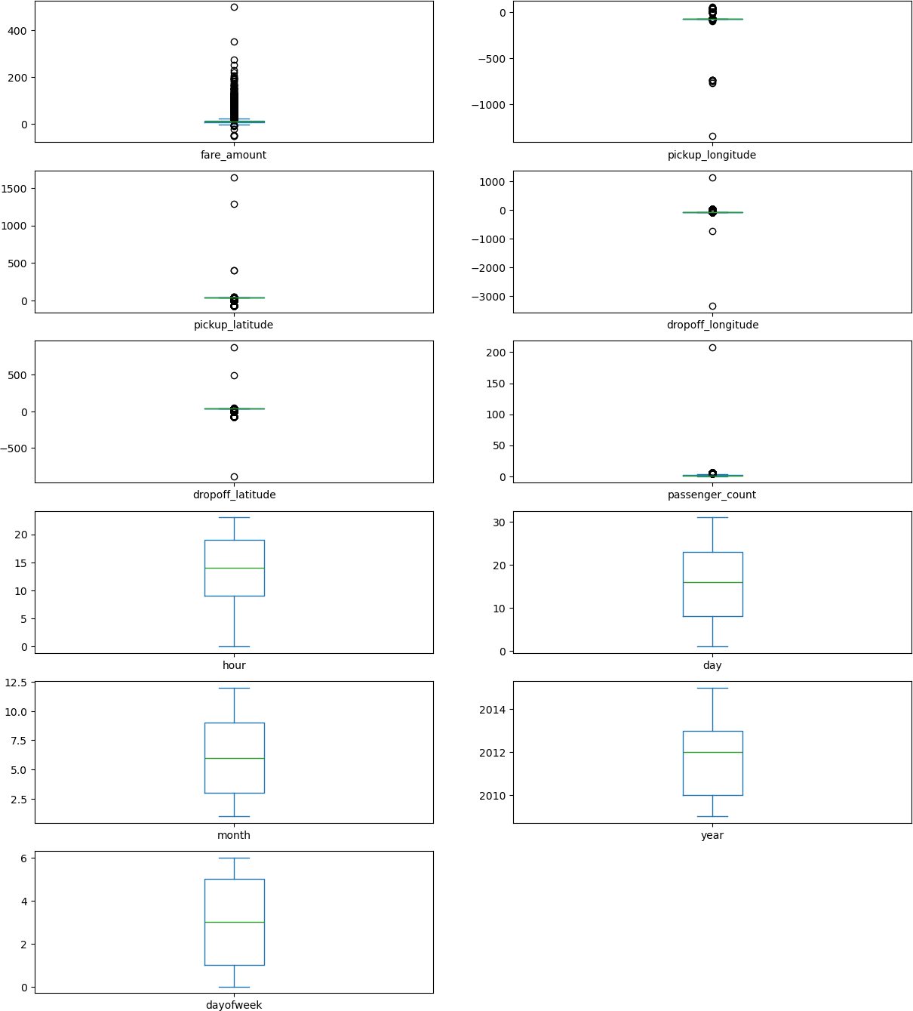
Out[53]:

In [62]:
def remove_outlier(df1, col): Q1 =df1[col].quantile(0.25) Q3= df1[col].quantile (0.75)
fare_amount Axes(0.125,0.786098;0.352273x0.0939024) pickup_longitude Axes(0.547727,0.786098;0.352273x0.0939024) pickup_latitude Axes(0.125,0.673415;0.352273x0.0939024) dropoff_longitude Axes(0.547727,0.673415;0.352273x0.0939024) dropoff_latitude Axes(0.125,0.560732;0.352273x0.0939024) passenger_count Axes(0.547727,0.560732;0.352273x0.0939024) hour Axes(0.125,0.448049;0.352273x0.0939024)
day Axes(0.547727,0.448049;0.352273x0.0939024) month Axes(0.125,0.335366;0.352273x0.0939024)
year Axes(0.547727,0.335366;0.352273x0.0939024) dayofweek Axes(0.125,0.222683;0.352273x0.0939024)
dtype: object

IQR= Q3 - Q1
lower_whisker= Q1-1.5*IQR upper_whisker= Q3+1.5*IQR
df[col] = np.clip(df1[col], lower_whisker, upper_whisker)
return df1
def treat_outliers_all(df1, col_list):
for c in col_list:
df1 = remove_outlier(df, c)
return df1

In [63]:
df = treat_outliers_all(df,df.iloc[:, 0::])

In [64]:
df.plot(kind = "box",subplots = True,layout=(7,2),figsize=(15,20))

Out[64]:
fare_amount Axes(0.125,0.786098;0.352273x0.0939024) pickup_longitude Axes(0.547727,0.786098;0.352273x0.0939024) pickup_latitude Axes(0.125,0.673415;0.352273x0.0939024) dropoff_longitude Axes(0.547727,0.673415;0.352273x0.0939024) dropoff_latitude Axes(0.125,0.560732;0.352273x0.0939024) passenger_count Axes(0.547727,0.560732;0.352273x0.0939024) hour Axes(0.125,0.448049;0.352273x0.0939024)
day Axes(0.547727,0.448049;0.352273x0.0939024) month Axes(0.125,0.335366;0.352273x0.0939024)
year Axes(0.547727,0.335366;0.352273x0.0939024) dayofweek Axes(0.125,0.222683;0.352273x0.0939024)
dtype: object

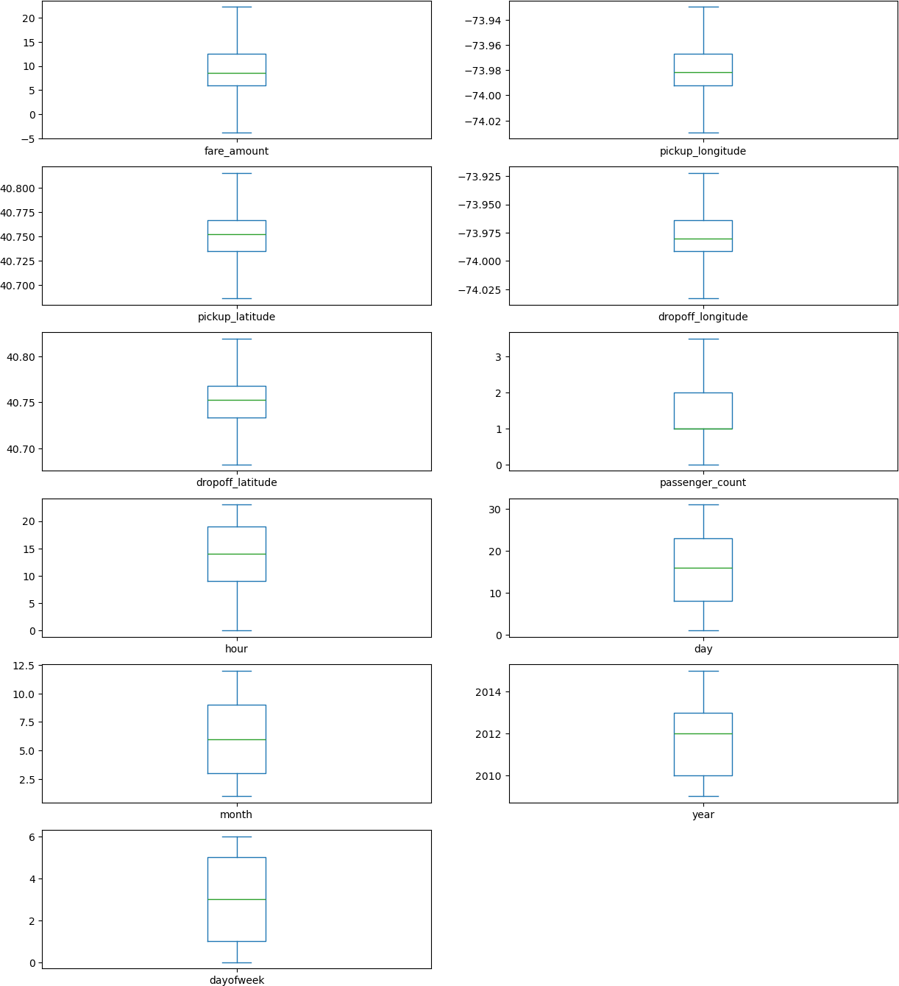

In [65]:
pip install haversine
Collecting haversine
Downloading haversine-2.9.0-py2.py3-none-any.whl.metadata (5.8 kB) Downloading haversine-2.9.0-py2.py3-none-any.whl (7.7 kB)
Installing collected packages: haversine Successfully installed haversine-2.9.0
Note: you may need to restart the kernel to use updated packages.

In [72]:
import haversine as hs travel_dist = []

for pos in range(len(df['pickup_longitude'])): long1 = df['pickup_longitude'][pos]
lati1 = df['pickup_latitude'][pos]
long2 = df['dropoff_longitude'][pos]

lati2 = df['dropoff_latitude'][pos] # <-- corrected from 'dropoff_lloc1'

loc1 = (lati1, long1) loc2 = (lati2, long2)

c = hs.haversine(loc1, loc2) travel_dist.append(c)

df['dist_travel_km'] = travel_dist df.head()

Out[72]: | fare_amount |  | pickup_longitude | pickup_latitude | dropoff_longitude | dropoff_latitude | pa
 | 0 | 7.5 | -73.999817 | 40.738354 | -73.999512 | 40.723217
 | 1 | 7.7 | -73.994355 | 40.728225 | -73.994710 | 40.750325
 | 2 | 12.9 | -74.005043 | 40.740770 | -73.962565 | 40.772647
 | 3 | 5.3 | -73.976124 | 40.790844 | -73.965316 | 40.803349
 | 4 | 16.0 | -73.929786 | 40.744085 | -73.973082 | 40.761247
 | C |  |  |  |  |  | C

In [73]:
df = df.loc[(df.dist_travel_km>=1) |(df.dist_travel_km<=130) ] print("Remaining obervation:" , df.shape)

Remaining obervation: (200000, 12)

In [74]:
incorrect_coordinates =df.loc[(df.pickup_latitude>90) | (df.pickup_latitude< -90)|
(df.dropoff_latitude>90) | (df.dropoff_latitude< -90 (df.pickup_longitude>180)| (df.pickup_longitude< -180 (df.dropoff_latitude>90) | (df.dropoff_latitude< -90
]

In [75]:
df.drop(incorrect_coordinates, inplace = True, errors ='ignore')

In [76]:
df.head()

Out[76]: | fare_amount |  | pickup_longitude | pickup_latitude | dropoff_longitude | dropoff_latitude | pa
 | 0 | 7.5 | -73.999817 | 40.738354 | -73.999512 | 40.723217
 | 1 | 7.7 | -73.994355 | 40.728225 | -73.994710 | 40.750325
 | 2 | 12.9 | -74.005043 | 40.740770 | -73.962565 | 40.772647
 | 3 | 5.3 | -73.976124 | 40.790844 | -73.965316 | 40.803349
 | 4 | 16.0 | -73.929786 | 40.744085 | -73.973082 | 40.761247
 | C |  |  |  |  |  | C

In [77]:
df.isnull().sum()

Out[77]:

In [78]:

Out[78]:

In [79]:
corr = df.corr() corr
fare_amount 0
pickup_longitude 0
pickup_latitude 0
dropoff_longitude 0
dropoff_latitude 0
passenger_count 0
hour 0
day 0
month 0
year 0
dayofweek 0
dist_travel_km 0
dtype: int64
sns.heatmap(df.isnull())
<Axes: >
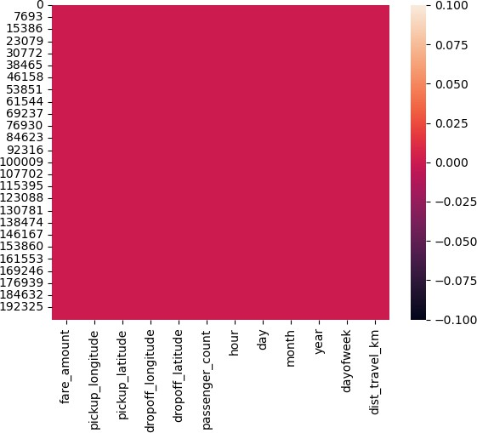

Out[79]:
fare_amount | pickup_longitude | pickup_latitude | dropoff_longitude | drop

fare_amount 1.000000 0.154069 -0.110842 0.218675
pickup_longitude
0.154069
1.000000
0.259497
0.425619
pickup_latitude -0.110842 0.259497 1.000000 0.048889
dropoff_longitude
0.218675
0.425619
0.048889
1.000000
dropoff_latitude -0.125898 0.073290 0.515714 0.245667
passenger_count
0.015778
-0.013213
-0.012889
-0.009303
hour -0.023623 0.011579 0.029681 -0.046558
month 0.030817 0.001169 0.001562 0.002391
day
0.004534
-0.003204
-0.001553
-0.004007
year
0.141277
0.010198
-0.014243
0.011346
dayofweek 0.013652 -0.024652 -0.042310 -0.003336
dist_travel_km
0.786385
0.048446
-0.073362
0.155191
C
C

In [80]:
fig,axis = plt.subplots(figsize= (10,6)) sns.heatmap(df.corr(), annot = True)

Out[80]: <Axes: >
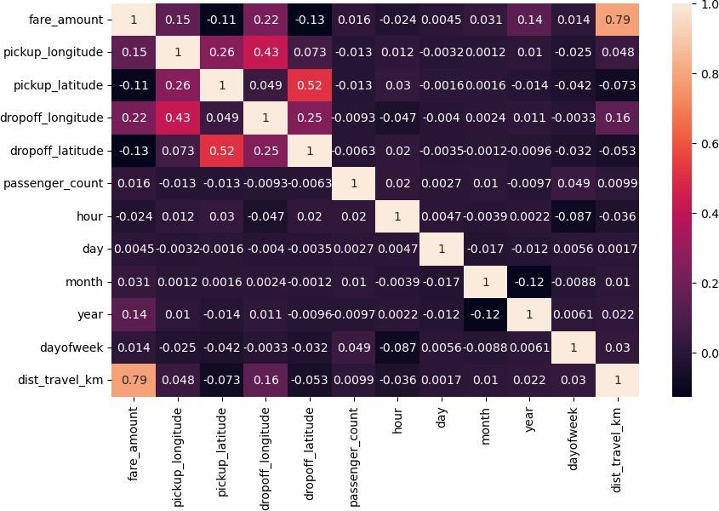

In [81]: | df.dtypes
Out[81]: | fare_amount | float64
 | pickup_longitude | float64
 | pickup_latitude | float64
 | dropoff_longitude | float64
 | dropoff_latitude | float64
 | passenger_count | float64
 | hour | int32
 | day | int32
 | month | int32
 | year | int32
 | dayofweek | int32
 | dist_travel_km | float64
 | dtype: object

In [84]:
x = df[['pickup_longitude', 'pickup_latitude','dropoff_longitude', 'passenger_count

In [85]:
y = df['fare_amount']

In [87]:
from sklearn.model_selection import train_test_split
x_train, x_test, y_train,y_test = train_test_split(x,y,test_size = 0.33)

In [89]:
from sklearn.linear_model import LinearRegression regression = LinearRegression()

In [90]:
regression.fit(x_train,y_train)

Out[90]:

LinearRegression()
?
ession i
▾ LinearRegr

In [91]: | regression.intercept_
Out[91]: | 3256.513201301484
In [92]: | regression.coef_
Out[92]: | array([ 3.10758620e+01,  5.77478080e-03,  -3.27278737e-02, | -1.85910612e+01, 3.38249411e-03,  1.86084919e+00]) | 1.27429851e+01,  5.89651957e-02, | 5.41800674e-02,  3.71366494e-01,

In [93]:
prediction = regression.predict(x_test)

In [94]:
print(prediction)
[13.00853888 7.57316671 13.25903141 ... 13.71316448 13.18778424
11.11547073]

In [95]:
y_test

Out[95]: | 1086 | 22.25
 | 96074 | 11.30
 | 104027 | 12.50
 | 133659 | 7.50
 | 58255 | 7.70
 |  | ...
 | 27046 | 10.50
 | 178816 | 14.00
 | 42112 | 12.50
 | 53060 | 14.50
 | 83308 | 8.90
 | Name: | fare_amount, Length: 66000, dtype: float64

In [97]:
from sklearn.metrics import r2_score r2_score(y_test,prediction)

Out[97]: In [100…

Out[100… In [ ]:
0.6584561379465177

from sklearn.metrics import mean_squared_error MSE = mean_squared_error(y_test,prediction)
MSE
10.140972773285915

